VETERAN FOURS HEAD 2025

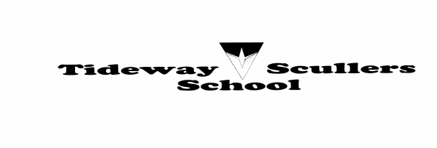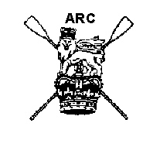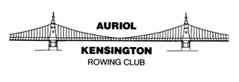

Bad Weather Procedure – Race GO/NOGO

The safe conduct of the race and the safety of the competitors is the number-one priority of the Organising Committee. A key element in determining the safe conduct of the race is the weather conditions in the area of the course immediately before, during and immediately after the race.

The Organising Committee will monitor the following elements in order to come to a balanced opinion concerning the running of the race:

- Ambient temperature

- Wind direction and strength

- Precipitation (rain, snow, hail)

- River flow rate (potentially increased from previous heavy rainfall) via the PLA flag system

- Visibility (either mist/fog or precipitation)

- Lightning/heavy storm

There are a number of absolute weather parameters that will lead to a race NOGO. These are specified below. In addition, a combination of factors may make the river unsafe to marshal/race even though all individual elements appear to be ‘in range’.

The race is run on an outgoing tide (ebb). Therefore conditions will tend to become more benign with time as the tide drops.

The marshalling area (Kew Road bridge to the Ship public house) is a SSE to NNW direction (boats facing into the stream until ordered to turn and proceed to the start line).

The actual race is primarily run from a NNW to SSE direction.

The race course is a large S-shape along the NNW to SSE direction. This means that wind will affect different parts of the course in different ways. As the course runs from Chiswick to Putney, there is a virtual 180-degree direction change, turning a positive wind into a negative wind or vice versa.

In broad terms, wind coming from the 90-degree axis North to East is more likely to negatively affect the condition of the course.

Conversely, wind coming from the 90-degree axis West to South is less likely to have a negative effect on the condition of the course, often associated with rough water.

The key decision for the Organising Committee is to decide if the race should be cancelled before race day. They have to balance the impact of competitors assembling for the race only for it to be cancelled at the last minute against cancelling it before race day only to have perfect conditions on the day. (This has happened in the past)

Organising Committee action timeline:

7 days leading up to race date
The Safety Adviser, Chief Marshal and Chief Umpire will monitor actual and forecast weather conditions. In addition, they will assess the impact of these conditions on the river along the racing course.

1–3 days before race date
The Safety Adviser, Chief Marshal and Chief Umpire will decide, based on current and forecast weather conditions, if the race is likely to be run. If the race is a NOGO, all competitors will be advised via the existing communication channels that the event has been cancelled.

4 hours before race start time
The Safety Adviser, Chief Marshal and Chief Umpire will decide, based on current and forecast weather conditions, if the race is likely to be run. If the race is a NOGO, all competitors will be advised via the existing communication channels that the event has been cancelled. In addition, competitors should check the X (Twitter) feed (https://twitter.com/vetfourshead) and key personnel will be advised to stop large-scale boating. We are not able to stop people boating for non-race outings if they so choose, based on their own risk assessments.

1.5 hours before race start time
The Safety Adviser, Chief Marshal and Chief Umpire will decide, based on current and forecast weather conditions, if the race is likely to be run. If the race is a NOGO, boating will be stopped and marshals will be tasked to go afloat and advise any competitors already on the water that the race has been cancelled.
This is the crucial GO/NOGO decision point. If there is any doubt, a full course inspection may be undertaken and/or advice taken from individuals positioned at different points along the course.

In addition, advice and input will be sought from the PLA and the Coastguard/RNLI. These agencies can advise that the race is a NOGO.

A delay may be put in place if, after assessing the conditions, the trend and up-to-date weather forecasts, it is felt that the race can be more safely run at a slightly later time.

A “short course” option might be available for 2025 with course being shortened to finish before Hammersmith Bridge.

There are two aspects to this decision. Is it safe to marshal the number of boats in the event, and is it safe for them to race? The situation can arise where it is unsafe to marshal the boats but it may appear safe for them to row due to the prevailing wind speed and direction.

10 minutes before race start time
The Chief Marshal will do an all-stations broadcast as a final check that there are no reasons to cancel or delay the race.

During the race
The Safety Adviser, Chief Marshal and Chief Umpire will constantly monitor the situation regarding weather and river conditions. If required, the race can be delayed or cancelled based on this assessment.

The Organising Committee is not in a position to judge the capability of individual crews to cope with specific conditions. Hence decisions on whether the race will go ahead will assume competence to cope with typical seasonal Tideway conditions. Each crew must take responsibility for assessing the conditions in relation to their own ability, and should not boat if they have doubts, irrespective of whether or not the race is going to be run.

Please read the separate Safety and Marshalling Instructions (available to download on the race website) for contact points in the event of problems.

Weather and stream parameters

Factor | 3 | 2 | 1 | 0
Wind speed | Force 5 | Force 3–4 | Force 1–2 | Force 0
Wind direction |  | NE | WS
PLA flag status (1) | Red | Yellow |  | Green
 | Take Action | Be Prepared | Be Aware | None
Precipitation (2)  Air Temperature |  | < 4°C |  | > 8°C
Visibility (3) | < 200m | Reduced |  | Good

1 PLA flag status http://www.pla.co.uk/
2 Precipitation http://www.metoffice.gov.uk/public/weather/warnings
3 Visibility https://weather.metoffice.gov.uk/warnings-and-advice/uk-warnings#?date=2025-10-07

Any parameter that meets the column 3 criteria would mean the event is cancelled.
Other columns show the perceived risk level to the event, severity increasing by column number. Any combination of factors may mean restrictions are put on the event escalating to cancellation if necessary.

