VETERAN FOURS HEAD 2016
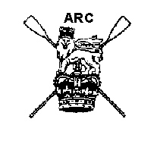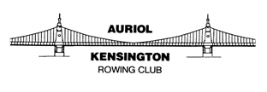

SAFETY AND MARSHALLING INSTRUCTIONS
FOR CAPTAINS, COXSWAINS AND STEERS

To be rowed on Sunday 13 November 2016, starting at 10.32 a.m., from the Mile Post, Putney to Barker’s Rails, Chiswick on the flood tide.
THE TWO MINUTES’ SILENCE WILL BE HELD AT 10.30AM, ONCE THE CREWS ARE MARSHALLED. THIS WILL BE INDICATED BY THE MARSHALLS.

Safety
SAFETY IS THE RESPONSIBILITY OF ALL. A crew that is unaware of these instructions or simply ignores them is a danger to itself and all other crews. A crew that is considered dangerous will be prevented from racing or, if acting dangerously during the race, risks a time penalty or disqualification.
- It is the responsibility of club captains to ensure all their coxes and steers (a) are competent to be ‘masters’ of the vessel, (b) have read and know the relevant parts of the Tideway Code –http://www.thames-rrc.org/files/safety/Pocket_guide_colour_A4_spread.pdf – and (c) as well as having read these instructions also understand them.
- All crews must comply with the regulations laid down in the British Rowing Rules of Racing and Row Safe Code. In particular, club captains must ensure that all competitors are aware of sections 1.9 and 2.1 of Row Safe, regarding safety aids and swimming ability.
- All crews should be aware of the Thames Regional Rowing Council’s Discipline Code which is within the documents on this website.
- All crews should be aware of the race abandonment plan and emergency incident management plans that are at the end of this document. In addition also please take careful not of the bad weather procedure document on the website and to check in the week of the race for weather updates on the site. All crews must be aware of the Ebb Tide Flag Warning system this is also on the website.
- If the organising committee decide to shorten the course, then the race will start at the St Paul’s Ramp but still finish at Barker’s Rails. Please check the website in the week before the race for race-status updates. See the marshalling map at the end of this document for the shortened course.
- It is the responsibility of club captains and crews to ensure that there is a competence within crews to row in the conditions prevailing on the day (irrespective of any decision by the organisers to run all or some of the events in the competition) including health and fitness to do so. Competitors are expected to carry out their own risk assessment on the day of the race, taking into account their personal circumstances and fitness. All participants must be aware of their responsibility to themselves and others with regards to their ability to take part safely in the conditions as they find them on the day of the event. Please note special conditions relating to any novice rowers included in any events entered; these notes can be found on the relevant sections of the British Rowing entry system, and at http://www.vetfourshead.com/generalinformation/.
- It is the responsibility of individual crews to ensure that their equipment fully meets the requirements of the British Rowing Row Safe Code, including issues of buoyancy, the integrity of closed compartments, bow balls, heel restraints and steering gear. The Chief Umpire will decide appropriate penalties for crews found failing to comply with the code; these will include disqualification for serious breaches.
- Mechanical Breakdown/Failure should a crew have a mechanical steering failure it is essential that the crew stop racing and notify an official of the problem. It important that crews do not put themselves at risk by trying to finish the race with defective steering.
- It is recommended, but is not mandatory, that crews carry a mobile phone on board. If there is an emergency and the emergency services need to be called, either using a mobile phone held by the crew or via a spectator’s phone, when speaking to the emergency services operator [dial 999] the services of the Coastguard should be requested.
- All crews must have one member who can speak English.
- All domestic boats must carry compliant and the correct three letter and three digit code to designate club and boat number (e.g. TSS198). Foreign entries in their own boats may have a code supplied through the entry system. Non-compliant boats may be disqualified.
- Eight safety launches will be in position along the course. Refer to the map below for details of location. Anyone in need of assistance should notify a marshal or observer who will be able to summon help on his/her radio. Crews should use the International Safety Signal (slowly and repeatedly raising and lowering arms outstretched to either side) when asking for help.

LOCATIONS OF SAFETY BOATS
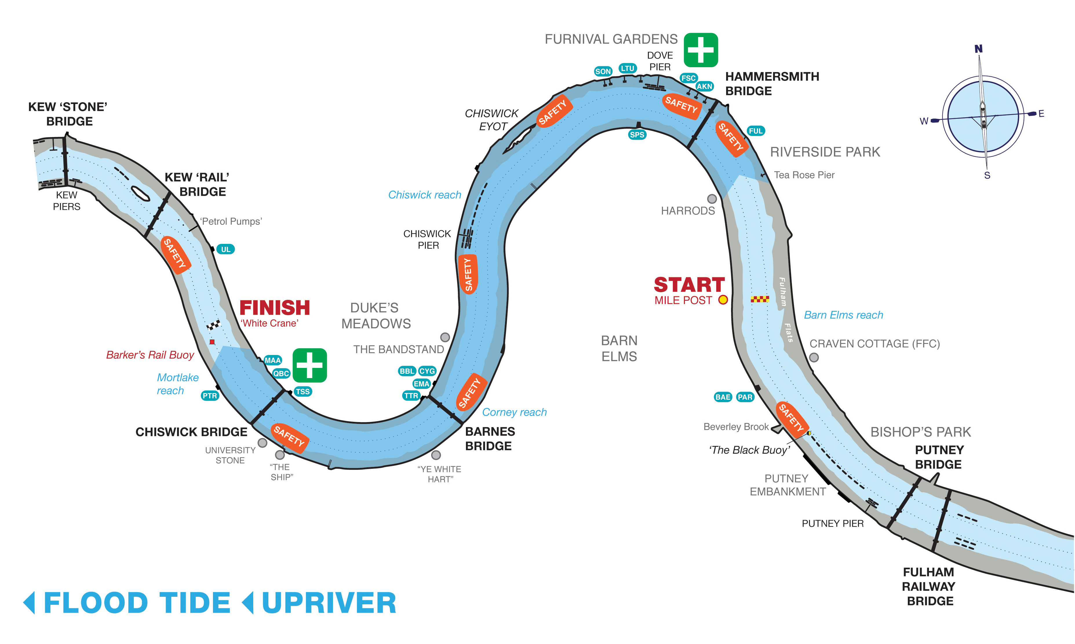

- Safety and marshalling launches will follow the last boat(s) back to the Putney boathouses. This will be done with reasonable attention as to which is the last boat on the river that is returning to Putney. Any crews that stop and disembark on the way back, but then subsequently re-boat, will not be part of the safety roll-up of the race.
- It is advised that, in the interests of spectator and bystander safety, supporters and coaches following the race on bicycles take due care.
- If a member of the crew should fall out of the boat, the crew must stop and help. Shout loudly to any crew behind to warn them. Following crews must take avoiding action and all crews must alert rescue craft immediately.
- Ambulances and First Aid facilities will be available at:
  - Chiswick Bridge (Middlesex): Tideway Scullers School boathouse (first aid); Mortlake, Anglian & Alpha (ambulance)
  - Hammersmith (Middlesex): Lower Mall and Mall Road (ambulance and first aid).
  - Chiswick Pier House (Middlesex) doctor
- The river is closed to other river users from 9.30 a.m. until 12.30 p.m. Prior to and post the river closure normal navigational rules apply and must be known and obeyed. During the race crews must follow the race rules, but this does not absolve a crew from its responsibility to navigate a safe course at all times.
- Normal Tideway navigation rules must be obeyed (U10 of 2016, http://www.pla.co.uk/assets/u10of2016-mortlaketobarnelmsreach-riverclosures-2016-17headoftheriverraces.pdf) except where specified by these instructions during the river closure. Crews seeking further clarification should consult the PLA or TRRC websites, or ask club or regional water safety advisers.
- British Rowing insurance for the event will only be valid for UK residents defined as being resident for six [6] months or more. Competitors who do not meet these criteria will not be covered by this insurance policy.
- Crews affiliated to any rowing association outside of Britain that is recognised by British Rowing or FISA do not have register with British Rowing but must have third-party liability insurance.

SPECIAL CAUTION: DOVE PIER NAVIGATION
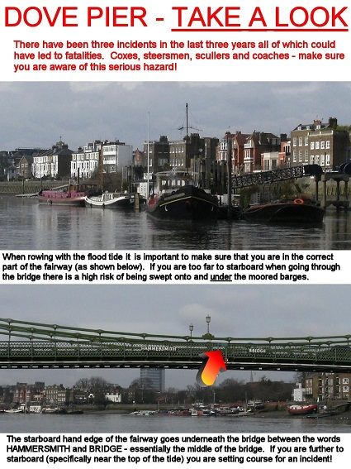

Marshalling Instructions

Numbers
Number collection

Please note the new arrangements for the 2016 race: numbers will be available at designated collection points on the morning of the race. Please collect your number before going afloat for the race.

IMPORTANT: Crews must ensure that BROE is showing the correct host club for their boat by 5 p.m. on Wednesday 9 November.

- Crews boating from Putney collect their numbers from THAMES ROWING CLUB
- Crews boating from Hammersmith collect their numbers from SONS OF THE THAMES
- Crews boating from the Civil Service Boathouse (aka Cygnet/Barnes Bridge Ladies) and Thames Tradesmen should go direct to their host clubs, where their numbers will be waiting.
- Crews boating from Tideway Scullers School and all clubs upstream of Chiswick Bridge collect their numbers from TIDEWAY SCULLERS SCHOOL

collection point | host clubs
Thames Rowing Club | Thames, Barn Elms, Crabtree, Imperial College, King’s College School, London, Parr’s Priory, Putney High School, Vesta
Sons of the Thames | Sons of the Thames, Auriol Kensington, Furnivall
Civil Service (Barnes Bridge Ladies/Cygnet) | Barnes Bridge Ladies, Cygnet
Thames Tradesmen | Thames Tradesmen
Tideway Scullers School | Tideway Scullers School, Mortlake, Anglian & Alpha, Putney Town, Quintin, Twickenham, University of London,

Displaying numbers

- Crews will be issued with one Empacher number plate and two linen numbers.
- The Empacher number plate must be securely affixed to the bow of the boat. Crews without a bow number cannot be guaranteed a finishing time.
- One linen number must be securely fastened – at least at each corner, but preferably with six safety pins – to the back of the bow person (NOT the cox) so as to be visible when racing (i.e. on racing kit).
- The second linen number should be fixed to the back of the bow person so as to be visible in transit and when marshalling prior to the race (i.e. on warm-up kit).

Number return
- After the race, Empacher number plates must be returned, undamaged, to the race committee on the day, or by 16 November if sent by post.
- On the day, numbers can be returned to the boxes at the number collection points.
- Those wishing to return their numbers by post should send them to the Treasurer, Jimmy Pigden, at 19 Walsingham Gardens, Stoneleigh, Surrey KT19 0LS.
- Numbers must not be posted back to Tideway Scullers School or any other rowing club.
- For the 2016 race, there is no number deposit to be collected when the number is returned. Instead, crews that have not returned their number by 16 November, or have lost or damaged their number by whatever means, will be charged £15 for its replacement.

Boating
- Crews must not boat unless their equipment is in full working order.
- Crews are advised to boat in good time so as to reach their marshalling position in good time. It is the absolute responsibility of crews and their captains to ensure that this happens.

Marshalling Positions
- All crews must be in their marshalling positions by 10:15 a.m. No crews may ‘slot in’ to their divisions by boating late. Any crew doing so risks a time penalty or disqualification.
- Crews will assemble in four divisions:
  - Division 1 (crew numbers 1 to 80) will marshal on Middlesex between the upstream end of Fulham Football Ground and Putney Pier, with bows pointing towards Putney Bridge and blades in contact with the bank (if safe) [Tideway Code page 23 Section 2.6 BP No. 3]. Crew 1 will be just upstream of the Fulham Football Ground.
  - Division 2 (crew numbers 81 to 135) will marshal on Surrey between the Black Buoy and halfway between the Mile Post and Barn Elms boathouse, with bows pointing towards Putney Bridge and blades in contact with the bank (if safe) [Tideway Code page 23 Section 2.6 BP No. 3]. Crew 81 will be halfway between the Mile Post and Barn Elms boathouse.
  - Division 3 (crew numbers 136 to 195) will marshal on Middlesex between Hammersmith Bridge and upstream end of Fulham Football Ground, with bows pointing towards Putney Bridge and blades in contact with the bank if safe [Tideway Code page 23 Section 2.6 BP No. 3]. The highest-number crew (i.e. 195, the last starter in the division) will be just upstream of Fulham Football Ground, and crew 136 will be the nearest to Hammersmith Bridge. Crews will proceed downstream when directed by the marshals after the departure of Division 1 and will take up the positions vacated by the crews in Division 1 as directed by the marshals.
  - Division 4 (crew numbers 196 to 240 or last crew) will marshal on Surrey from between halfway between the Mile Post and Barn Elms boathouse and Hammersmith Bridge, with bows pointing towards Putney Bridge and blades in contact with the bank if safe [Tideway Code page 23 Section 2.6 BP No. 3]. Marshalling will be the same as for Division 3, i.e. the highest numbered crew will be nearest to the Mile Post and the division will move downstream towards Putney after the departure of Division 2 as directed by the marshals, the highest-numbered crew being upstream of the Black Buoy.

MAP OF MARSHALLING POSITIONS
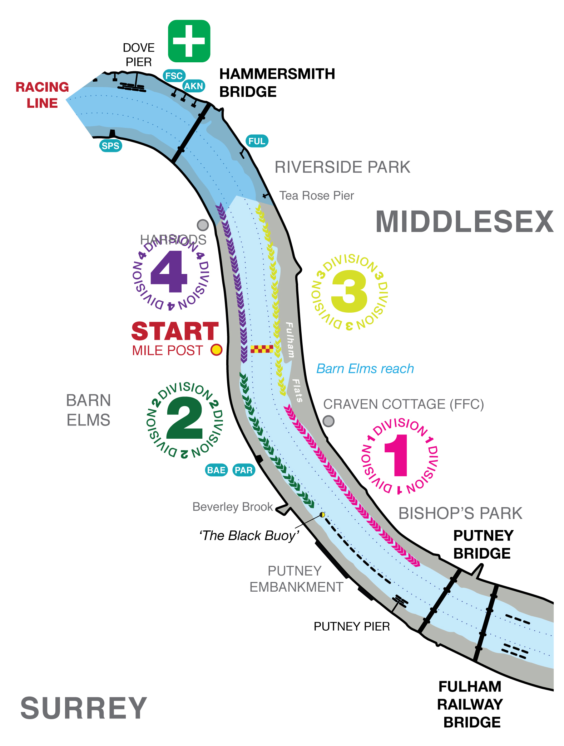

- Once established in their marshalling positions, crews must keep in single file in line astern with their bows pointing towards Putney Bridge and keep as close to the bank as possible. Boats must maintain their position against the tide and neither allow themselves to become bunched together or allow gaps to develop between adjacent crews.
- Crews must not row at or above race pressure between Chiswick Eyot and Putney Bridge after 9:45 a.m., unless specifically directed to do so by a marshal or observer.
- Crews arriving late to the start must wait on the Surrey bank, the St Paul’s side of the river, between Hammersmith Bridge and the St Paul’s School Boathouse, as near to the bridge as possible but ensuring they are at the rear of Division 4. Under no circumstances should crews attempt to cross the river after 10:15 a.m. unless instructed to do so by a marshal.

The Start of the Race
- The two minutes silence will be observed once crews are marshalled at 10.30am the start and finish will be signified by a hooter
- The race will start on time and without reference to absentees
- After the silence ends, marshals will sound a pneumatic horn and issue a verbal notice to crews. Crews in Division 1 should remove any kit that they do not wish to wear for the race.
- On instructions from marshals, crews will turn, taking their bows out into the centre of the river. Do not ‘spin turn’ close in to the shore.
- Crews will then proceed upstream to the start in numerical order, being sure to leave 1–2 lengths of clear water between crews.
- Crews will receive the instruction ‘Number … Go!’ from the Starter and timing will start at the Mile Post.

During the Race
- Coxswains and steers should maintain that which they consider to be their best course, but MUST fully give way to overtaking crews. Failure to observe this rule will lead to a time penalty or disqualification. ALL crews have a responsibility to avoid collision and may be penalised if judged to have contributed to the causes of a collision. Umpires and observers will be posted along the course.
- Crews must pass through the centre spans of Hammersmith, Barnes and Chiswick Bridges.

The Finish Area
- The finish line will be marked by a buoy and a white crane on the Middlesex bank. The finish is at Barker’s Rails on Chiswick Staithe riverside (W4 3TP), about 650 metres upstream of Chiswick Bridge. The finish line is NOT the red Barker’s Rails PLA navigation buoy.
- Crews must not easy on the finish line, but must paddle upstream towards the University of London boathouse before turning.
- The instructions of marshals at the finish must be quickly and accurately adhered to.

Returning Crews
- Crews returning to the Putney Town RC boathouse, and to clubs at Hammersmith and Putney, should turn to the Surrey bank and return on the Surrey side of the river all the way back to their boathouses. They must not cross to Middlesex at any point upstream of the Chiswick Pier crossing.
- Crews returning to the University of London, Mortlake, Anglian & Alpha, Quintin, Tideway Scullers School, Thames Tradesmen, Cygnet, Barnes Bridge Ladies or Emanuel should all turn to Middlesex.
- All crews disembarking at Quintin and Mortlake, Anglian & Alpha shall wait in single file and keep as close to the bank to allow crews returning downstream to pass freely.
- Any crews returning to the Hammersmith clubs that need to cross the racing line during the course will be asked to wait until a marshal gives permission to cross the river. For the purposes of this event, crews from Fulham Reach would be considered Hammersmith crews
- Above all, crews returning to their boathouses must not impede racing crews and must accordingly give way to these crews. Failure to do so may result in a penalty or disqualification.

CIRCULATION PATTERN AT THE FINISH
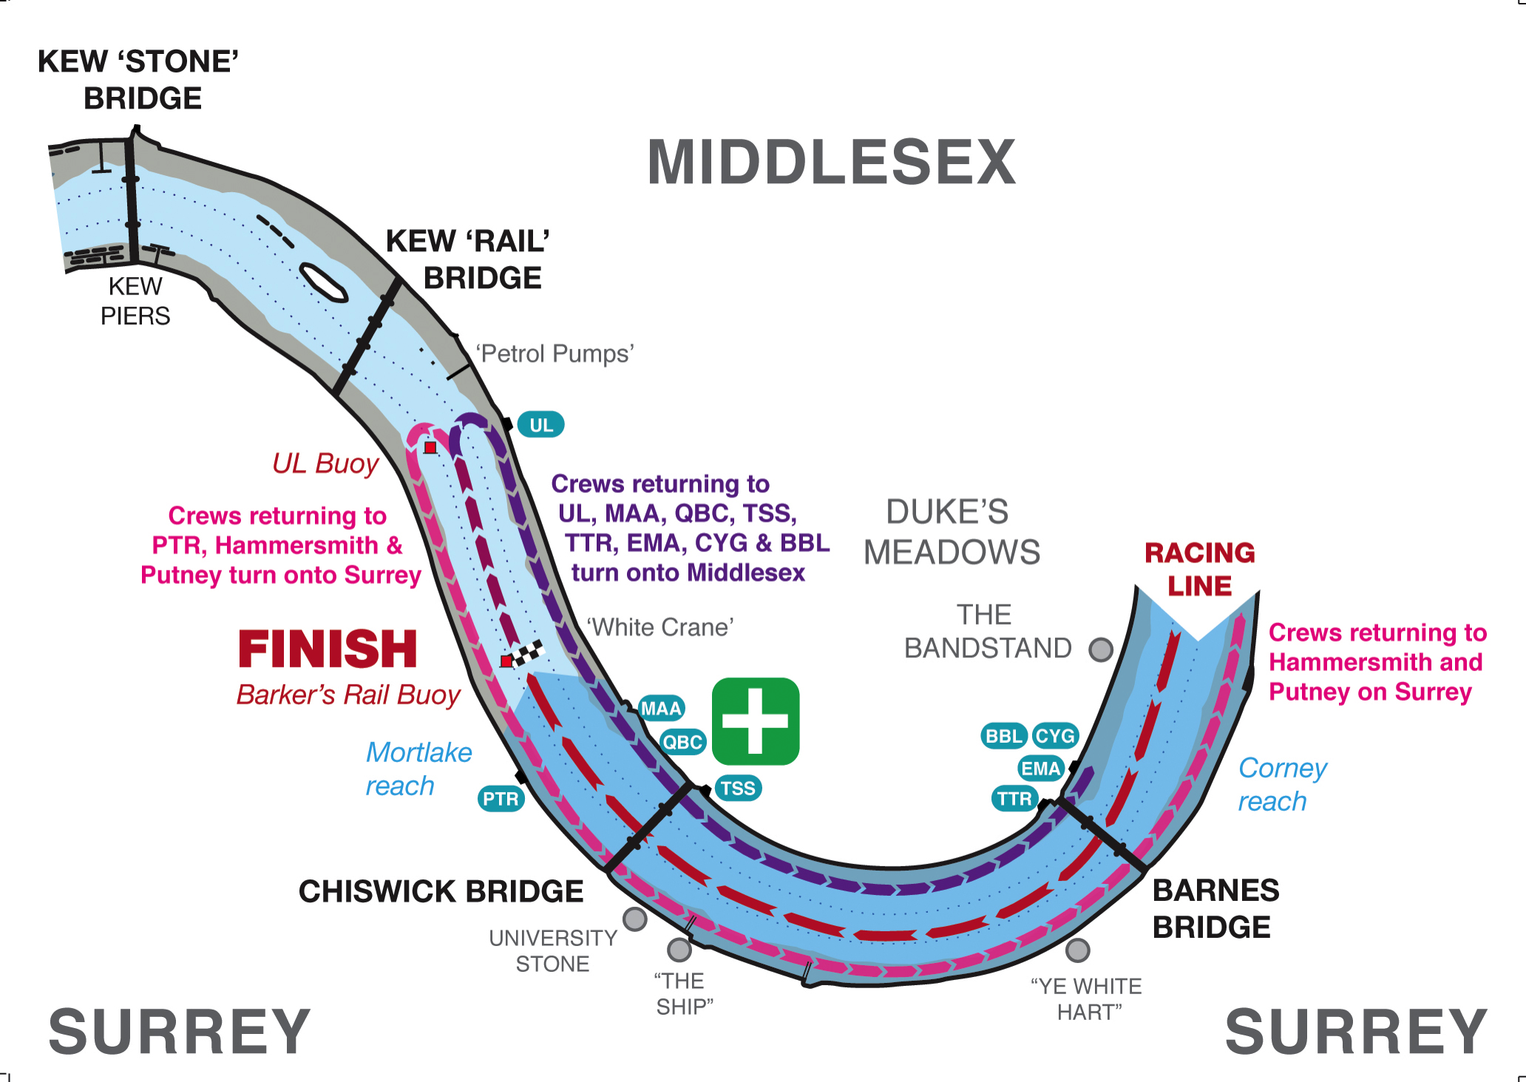

General Information
- The Veteran Fours Head is run for the benefit of the competitors. It endeavours to provide an enjoyable and fair race for all. Please obey marshals’ instructions at all times; however, this does not negate your responsibility as masters of the vessel for the safe navigation of your craft.
- Any complaints about the behaviour of other crews during the course of the race must be made to the Chief Umpire at the Chiswick Pier House (The Pier House, Corney Reach Way, London W4 2UG) within thirty [30] minutes of the last crew crossing the finish line. No complaints of this nature will be considered after the results have been announced.
- For the purposes of the event’s insurance, the event is deemed to commence at 9.30am. and ends at 12.30 p.m.

Abandonment Plan and Emergency Incident Management

In case the race has to be abandoned at any time while crews are marshalling or racing the following procedure will apply and be strictly adhered to:

Crews, on hearing continuous short blasts on air horns will immediately STOP. They will wait to be instructed on how and where to proceed by a marshal. They must maintain a sharp lookout for other crews in the vicinity who may not have heard or seen the warnings and are continuing with marshalling or racing. If necessary they must move to avoid any collision with such a crew.

Marshals will wait for instructions from the Chief Marshal, who will be in constant communication with the Race Safety Adviser, and once the cause and location of the problem has been determined he will proceed to put the abandonment plan into operation.

Depending on where crews have boated, whether or not the race has started and the number of crews still being marshalled, they may be asked to either paddle lightly upstream under the direction of the marshals (if they have boated from upstream of the marshalling area), or turn on to one of the banks and wait to be sent downstream if they boated from one of the clubs at or below the Mile Post. A crew may be asked to proceed upstream of all marshalling crews before turning on to one of the banks.

N.B. Please ensure that all crews check for any alterations to the marshalling instructions on the race website, www.vetfourshead.com, the day before the race. Notification of any such alterations will also be made via Twitter – @vetfourshead

In case of emergency, the call sign ‘Mayday, Mayday’ will be used, after which COMPLETE RADIO SILENCE must be maintained by all radio users except the person involved in the incident. They will communicate with Race Control who will, in turn, give instructions to all other marshals/umpires which instructions will relate to the severity and complexity of the incident.

Chief Marshal
November 2016

ONLY IN THE CASE OF A SHORTENED COURSE THE FOLLOWING MARSHALLING WILL COME INTO FORCE
